Dudley Children’s Occupational Therapy Service
The Sunflower Centre
John Corbett Drive
Stourbridge, DY8 4HZ
Tel: (01384) 366912 or (01384) 361369
Email: bchft.childrensot@nhs.net

Early Scissor Skills

Using scissors to cut out accurately requires the coordination of many skills including fine motor, eye-hand coordination and the ability to use both hands together. Scissor skills take time to develop and require the child to have adequate opportunities to practice with support initially to help develop their skills safely.

Getting Started
Different Types of Scissors
- Scissors with a looped handle (easi-grip) are easiest for children to use so may be a good starting point if they are struggling to hold standard scissors
- Shorter blades are usually easier to use
- Scissors should be sharp enough to cut materials to avoid frustration
- Always provide left handed children with left handed scissors to prevent the paper from bending and to ensure they can see where they are cutting
- Make sure scissors have a rounded rather than pointy tip for safety

Sitting Position
- Ideally the child should sit with their feet flat on the floor (or foot box) so they are stable and can use their hands freely. The table should be around elbow height
- Encourage the child to rest their elbows or forearms on the table for additional support if they seem unsteady

Typical Development of Scissor Skills
Establish what stage your child is currently at and aim to work towards the next stage
Stage 1
- Children often try and hold scissors with two hands to open and close (Figure A)
- Children will then start to place fingers in loops but not use the thumb at first (Figure B)
- Children begin to open and close the scissors with a mature grasp, thumb in the top loop, and middle finger at the bottom loop. Index finger below the bottom loop to provide stabilisation and to guide the direction of cutting (Figure C)
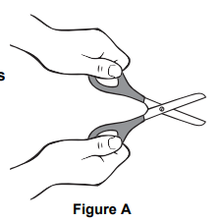
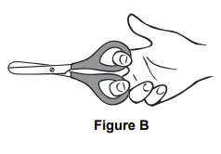
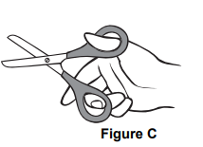
- Children learn to snip paper and will make random snips with no forward motion

Stage 2
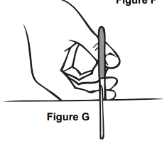
- Children will start to
push the scissors forward to cut across the paper (Figure G).
- Children start to cut on straight lines with some accuracy
- Children are starting to make cuts on curved lines and around corners, but without accuracy
- May start to turn the paper with “helping hand”

Stage 3
- Able to cut out simple shapes such as circles and squares with increasingly good accuracy.

Activity Ideas for Developing Scissor Skills
- See fine motor skills advice section for ideas to work on developing skill and strength with opening and closing hand action needed for using scissors.
- Encourage the child to hold the scissors the right way up (thumb on top) and to cut away from their bodies. Use hand over hand or physical prompting to readjust their hand position if they find it difficult to maintain this. Use a sticker or piece of coloured tape on the handle to help remind the child where to place the thumb on the scissors
- Use card initially as this is easier to hold and cut than paper e.g. empty cereal boxes or old greetings cards
- Start with materials that only require one snip e.g. straws, thin strips of card/paper, fringe the edges of card/paper, play dough sausage
- Start by asking children to cut along thick lines and gradually reduce the width as their skills develop
- Ask children to cut between two parallel lines and make gap between lines smaller as they progress
- Start with short lines and gradually increase length
- Use hand over hand guidance to demonstrate how to hold scissors and paper
- Enourage changes in direction and cutting around simple shapes, e.g. straight lines or relatively large circles and squares and then progress to more complex shapes.
- Use smaller sheets of card/paper as they are easier to manipulate, or cut away excess paper, to make the task easier
- Make snowflakes, paper chains, mosaic and collages with small pieces of paper/card/straws, snip top and bottom of a face drawn on paper/card to make ‘hair and beard’, cut out geometric shapes and stick them together to make a picture e.g. house, person, dog etc.

