School and Nursery Activities
Prewriting skills

Graphic skills
Encourage age appropriate pencil grasps.
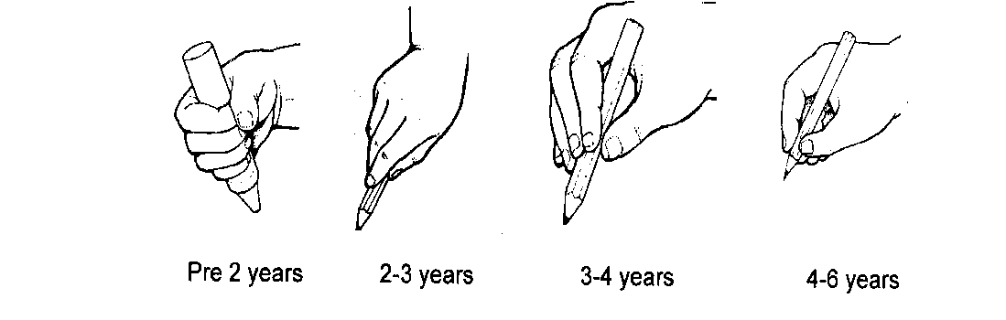
To encourage a tripod grasp and/or reduce tension of grasp -
- Use a short pencil to encourage the child to hold it with their fingers at the bottom.
- Use a pencil with a matt finish.
- Try pencils with a chunky barrel.
- Place an elastic band around the pencil shaft.
- Use of pencil grips.
- Cut a notch in the pencil to remind the child where to position their fingers on the pencil.
- Develop a pincer grasp (thumb and index finger). Use activities to develop this pincer grasp prior to picking up the pencil.
- Offer the pencil in a vertical position with the point towards the paper and ask the child to grasp the pencil between the thumb and index finger, then push the top of the pencil back into the webspace. If the child reverts to their original grasp, offer another colour and re-establish the desired grasp.

Pencil control
Encourage scribbling, linear and circular scribble. Progress to colouring in, keeping scribble within progressively smaller defined areas.

- Imitate (child sees you draw it first) and progress on to copying shapes (child doesn’t see you draw it)
- Colour in pictures, beginning with large shapes and decreasing size, as the child improves.

Pre-writing shapes
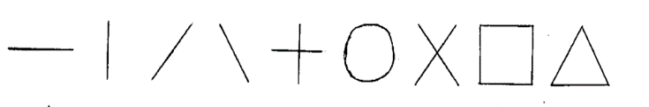
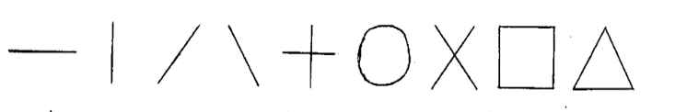
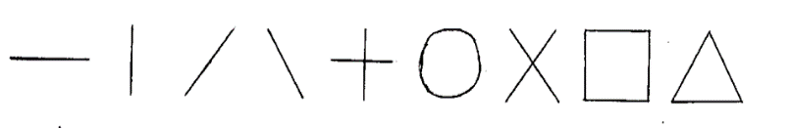

It is essential for children to develop pre-writing skills before they are able to write. A major component of pre-writing skills are the pre-writing shapes. These are the pencil strokes that most letters, numbers and early drawings are comprised of. They are typically mastered in sequential order, and to an age specific level.
Ideas to support development of these shapes:
- Prewriting strokes: focus initially on vertical, horizontal lines and circles. Progress onto diagonal lines once they are consistently forming the initial strokes. Use lots of imitation and demonstration, alongside hand over hand where possible.
- Play with shaving cream: Cover a surface with shaving cream, and have your child use their index finger to imitate, copy, trace or draw the pre-writing shapes. Try this activity on a vertical surface to add an extra challenge to this activity. For example, write on a mirror or on a tile wall while in the bathtub.
- Finger paint: Finger painting can be done on a table, easel, or by taping paper to the wall. Have your child cover the paper with paint and then use their fingers to imitate, copy, trace or draw the pre-writing shapes.
- Use sand or rice: Pour a small amount of sand on a table or a plate and have your child create these shapes with their fingers.
- Use a chalk board: Use chalk to create the pre-writing shapes, then use a wet paint brush or a wet finger to trace them and make them disappear. This creates two opportunities to practice.
- Play with Play Dough: Use little fingers to mould play dough into various shapes. This can be done by copying a shape, either on top of a shape (imitation) or by memory.
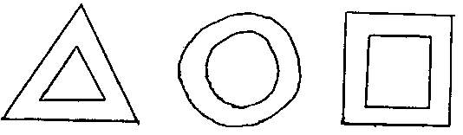
- Draw outline of shapes: Encourage child to draw between the lines. Use different types of medium such as felts, crayons, paints but also pushing cars, toy figures or balls around the shapes as if it were a road.
- Use large paper: Encourage your child to lie on their stomach and draw the shapes as big as they can. They can use the shapes and lines to make a bigger picture, like a collage.
- Draw between and around items: Place two small toys at either side of a large sheet of paper and get your child to draw a horizontal line between them. Then move the toys to the top and bottom of the paper so your child can practice a vertical line. To encourage your child to draw a circle, place a plate, cup or any other round item on the paper and ask your child to draw around the object.
- Use the whole body: lead the child around the strokes drawn on the pavement in large chalks or formed with a skipping rope on the ground. If possible have them trace the strokes on an interactive whiteboard using the whole body.
- Large arm movements: Practice strokes in the air with whole arm (big movement) then fingers (small movement) while verbalising the direction.
- Use music: If the child enjoys nursery rhymes, encourage the child to mimic the action. If they like music, forming prewriting strokes using the whole arm in beat to the music can help with understanding.
- Dot to dots: Have your child join dots that make up the above shapes.
- Using a tablet: For children who are interested in using a tablet, encourage them to watch and trace prewriting strokes on a screen. The following list is not a comprehensive as apps are constantly changing and being updated, however, it should gives a rough idea of what is available to help with different skills. Some may only be available on iPad or android. Focus on the first strokes listed above as they are listed in developmental order, try to avoid complex patterns as the child may not be ready. Use hand over hand to trace the shapes on the tablet if they will allow you.
  - Broom Broom - Prewriting app, draw lines and shapes which turn into roads with moving trains.
  - Lets play with trains - Prewriting app, draw lines and shapes which turn into tracks with moving trains.
  - Finger paint with sounds - Pre-writing app, choose a colour and draw on the screen. Each colour has a sound.
  - Ready to print - Created by an Occupational Therapist, Ready to Print is a tool for parents, therapists and educators to help teach pre-writing skills and build a strong foundation for beginning printers.
  - Let’s create - Early year’s app, make faces from fruit and food. Develops imagination, creativity, fine motor skills.
Once the pre-writing shapes are mastered, these same strategies can be used to practice letters. Using a multi-sensory approach to pre-writing shapes increases your child’s memory and motor learning to learn and maintain these skills.

Advice for Letter formations

General strategies
- Ensure the child has mastered prewriting strokes before moving onto letter formations.
- Teach correct letter formations in ‘letter families’, for example letters which follow similar patterns, i.e. c o a d g q/ r n m h.
- Imitate (child sees you draw it first) the correct letter formation then copy (child doesn’t see you draw it) the correct letter formation.
- Correct the child if they form the letter incorrectly when they are writing. Prompt them to problem solve to see if they can think for themselves how it should be formed.

Using movement
- Trace correct letter formations – trace the shape with the child’s finger initially, ensuring you start and finish the letter in the correct place.
- Use tactile letters to improve understanding of where a letter should start, alongside pencil direction. Emphasise the importance of starting and finishing letters in the correct place to help improve fluency.
- Complete dot to dot pictures that join up to make the letters.

Using the body
- Draw letters in the air with whole arm (big movement) then fingers (small movement) while verbalising the direction.
- Make the letter with string/masking tape on the floor and walk over it afterwards (first with eyes open then with eyes closed).
- Drawing letters on each other’s backs with their fingers. Identify the letter and state whether it was drawn correctly.

Craft ideas
- Make a letter and let the child trace it, colour it in, cut it out and paste it onto a bright background.
- Make a letter in sandpaper, felt, silk, with pipe cleaners etc and trace it with their fingers (first with eyes open, then with eyes closed).
- Spread finger paint onto a large sheet of paper or tray and finger paint the letter.
- Cut out a letter, cut it into a couple of pieces to make a puzzle. Get the child to put the letter together again and paste it down onto a bright background.
- Draw on different surfaces e.g. white boards, chalk boards, aqua mats, large pieces of paper, in shaving cream on a mirror or tray, in sand or rice, on a wall with a wet paint brush, on the an outside floor using chunky chalks etc. Be creative!
- Let the child make a roll out of clay or play dough and form the letter over a cardboard template. Make the letter out of an edible dough as an alternative and bake it.
- Make the letters b, d, p, q out of lollipop sticks and bottle top rings.
- Cut out a stencil of the letter or make a potato stamp and stamp a pattern for some wrapping paper.

Letter games
- Place a number of letter cards in a box. Have the child find all the cards of a certain letter. Use different fonts or different letter sizing to make it more interesting.
- Have letters cut out of cardboard. Have the child match the letters to the letter shape it was cut out from (find the correct “house” for the letter).
- Picture match – present the child with a few mixed letters, they must sort them out to make a word and match it to the correct picture. Start with small words using the letters that are often reversed.
- Picture letters – match the picture with the correct letter it starts with.
- Fill in the missing letters in words in sentences.
- Make the letters, b, d, p and q by drawing lines on a page and have the child print a circle next to the lines to make the letter you ask for. Use coloured circle stickers as an alternative.
- Make a domino game with letters. Match the letters as you would in a regular domino game.
- Make a lotto game with letters instead of pictures.
- Play memory game with letters on the cards instead of pictures

Scissor Skills Development & Advice

Using scissors to cut out accurately requires the coordination of many skills including fine motor coordination, bilateral coordination and eye-hand coordination. Scissor skills develop in a particular order and require the child to have adequate opportunities to practice with support initially to help with developing their skills.

Before a child learns to use scissors they need to have mastered certain skills first, such as;
- Be able to isolate fingers and combine individual movements of the thumb and fingers
- Co-ordinate hands, arms and eye movements together
- Have good joint stability in shoulder, forearm and wrist as this will create a stable base

Typical Development of Scissor Skills

18 months – 3 years:
- Often will try and hold scissors with two hands to open and close (Figure A)
- Children will then start to place fingers in loops but not use the thumb at first (Figure B)
- Will begin to open and close the scissors with a mature grasp, thumb in the top loop, and middle finger at the bottom loop. Index finger below the bottom loop to provide stabilisation and to guide the direction of cutting (Figure C).

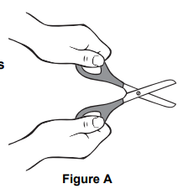
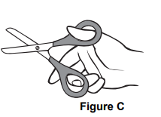
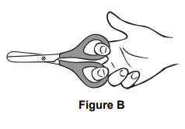

- Learns to snip paper around the age of 2 and will make random snips with no forward motion

3-4 years:
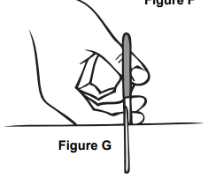
- At 3 years old children will start to push the scissors forward to cut the paper (Figure G).
- Will start to cut on straight lines with some accuracy
- Children at this age are starting to make cuts on curved lines and around corners, but without accuracy
- Have a better control of opening and closing the scissors only half way for improved fluency
- May start to turn the paper with “helping hand”

4-5 years:
- Able to cut out simple shapes such as circles and squares with increasingly good accuracy.

5-6 years:
- Able to cut out complex shapes and consistently uses a mature grasp
- Able to turn and manipulate the paper to a good standard
- Cuts smoothly and fluently along the paper

Helping develop the pre-requisite skills for using scissors

For developing open and close motion

- Pick up games – use tweezers or tongs to pick up small objects such as pom poms, small balls, small pieces of food.
- Squeezing games – using a water pistol or bubble gun to squeeze the trigger and squirt water or bubbles. Create a game by painting with water from pistol.

For developing Hand-eye coordination

- Maze activities
- Dot to dots
- Completing jigsaw puzzles
- Football blowing game – small balls of scrunched paper, use a straw to blow them into a goal
- Where’s Wally games
- Card matching games – snap, memory matching games

For developing upper limb stability

- Half push ups
- Wall push ups
- Animal walks – dog, bear, crab, snake
- Climbing frames
- Playing games in prone position
- Making shapes from Playdoh or putty
- Playing ball games in half kneeling

Advice for developing scissor skills

- Encourage the child to use their dominant hand. If they go to swap hands, allow them to have a short break and to continue to use the scissors in their dominant hand to further develop their skills.
- Encourage the child to hold the scissors the right way up (thumb on top) and to cut away from their bodies. Use hand over hand or physical prompting to readjust their hand position if they find it difficult to maintain.
- Encourage the idea that our two hands have different jobs, the “helper hand” holds the paper and the “doer” hand holds the scissors
- Using card as heavyweight paper provides additional stability – empty cereal boxes or old greetings cards
- Use smaller sheets of paper as they are easier to manipulate, or cut away excess paper, to make the task easier.
- Start by asking children to cut along thick lines and gradually reduce the width as their skills develop
- Ask children to cut between two lines rather than follow a line and make gap between lines smaller as they progress
- Start with short lines and gradually increase length
- Use a visual cue such as a sticker to support placement of the thumb on the scissors
- Use hand over hand guidance to support learning how to hold scissors and paper
- Encourage child to rest forearms on the table for additional support if lacking stability in upper limbs
- Ensure that child’s posture is supported at the table and can place feet fully flat on the floor for a stable base
- Alternative scissors such as; easi grip, spring loaded, large looped can be used to support grasp whilst developing skills
- Cut around simple shapes, e.g. straight lines or relatively large circles and squares and then progress to more complex shapes.
- Keep the line in view at all times when cutting i.e. if they are right handed, the line should be slightly to the left the blades of the scissors, if they are left handed, the line should be slightly to the right the blades of the scissors.
- Encourage the child to be as accurate as possible by prompting them to take their time and stay on the line.
- As their skills progress, encourage the child not to fully close the scissors with each snip, especially when cutting around curved edges.
- To further develop fluency, ensure they are cutting against the part of blade closer to the hinge, as opposed to snipping at the end of the scissors.
- Reward the child for trying and make it fun!

Fine motor activities

The following activities are to help further improve fine motor skills. Use a range of activities to see which are more effective and to have fun!
- Tongs, tweezers, connected chop sticks, strawberry hullers, clothes pegs: use these to pick up small objects for sorting, such as beads, marbles, beans, pompoms and cotton balls.
- Punch holes along strips of paper (1 to 2 inches wide) or along the edges of a sheet of paper or paper plate.
- Spray bottles: help water plants or spray the windows to clean, play with it in the bath, play outdoors in warm weather, add food colouring to make spray bottle pictures in the snow.
- Water guns and squirt toys: outdoor summer fun as well as in the bath.
- Sponges: squeezing to wring out the water is great for strengthening hands and forearms. Help wash the car, wash toys and dolls in the sink or bath, squeeze sponges on your friends during water play outdoors etc.
- Clay, therapy putty, Silly putty, play-doh, bread dough, modelling foam (Crayola Model Magic): these are all excellent materials for squeezing, squishing, pushing, pulling and moulding.
- Try hiding small objects (beads, pennies, beans) inside materials and then try pulling them out.
- Work on threading activities initially with a thick dowel and progress onto finer lace threading.
- Make a collage with small objects such as pasta, lentils, dried beans, tissue paper (rolled into small beads using pincer grip) etc.
- Plant seeds. Either the child picking up larger seeds individually for planting or sprinkling smaller seeds with index finger and thumb.
- Pop the bubbles on large or small bubble pack by pinching with thumb and index finger or by pushing down on bubbles when sheet is placed on a hard surface.
- Interlocking construction toys: Mega blocks/Duplo, bristle (Krinkles) blocks, Lego, Tinkertoys and K'nex.
- Activities around the home – cooking – stirring, rolling, kneading, mixing ingredients.

If you have any questions, please contact the department.

